How to process cassava to cassava flour
www.youtube.com
Type on the Search button – how to process cassava to cassava flour
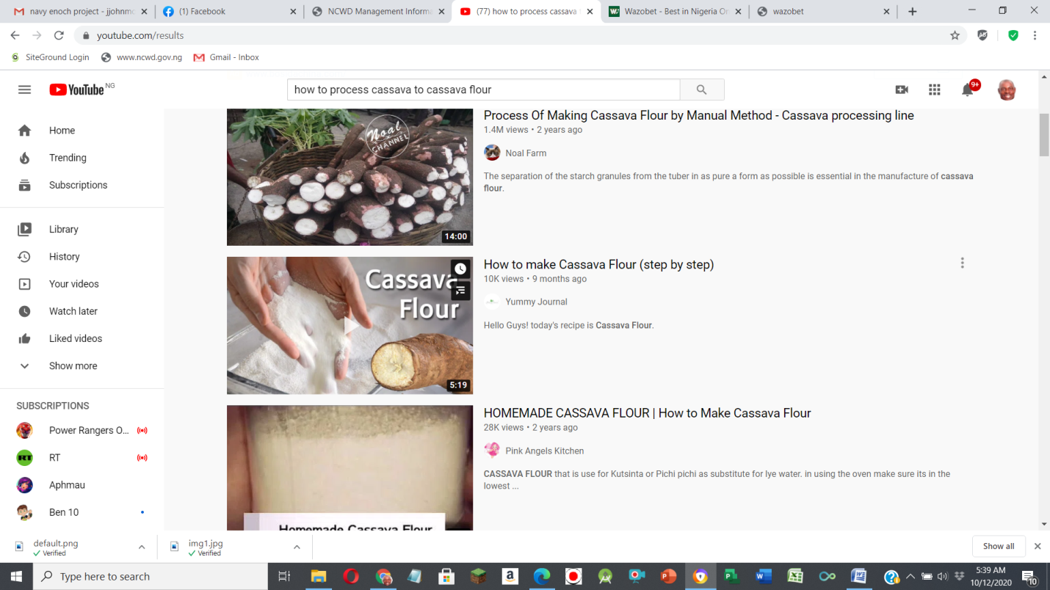

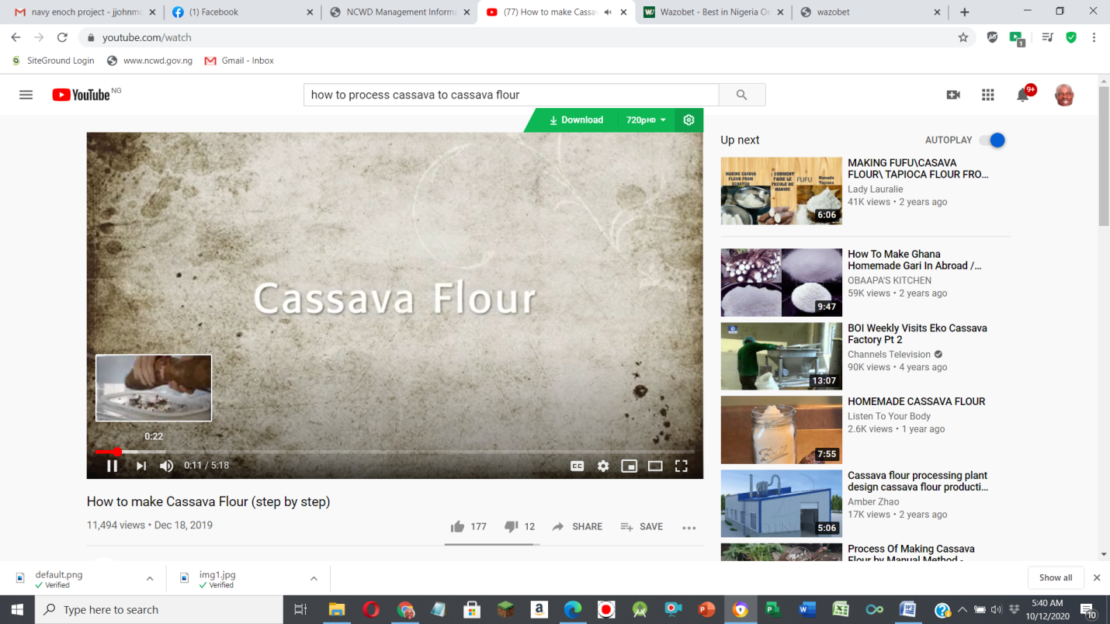

To download copy the address, example
https://www.youtube.com/watch?v=d2U-vxyx0LY
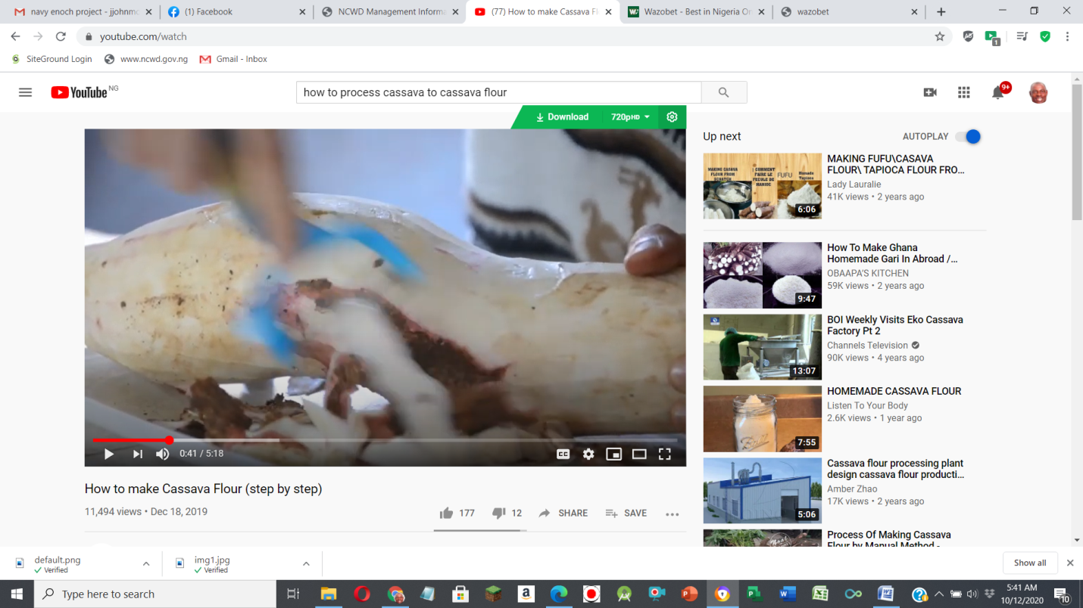

Change to
https://www.ssyoutube.com/watch?v=d2U-vxyx0LY and press enter
It will change to a format you can download to your computer system

How to preserve your yams
https://www.youtube.com/watch?v=eH7BzoEYGJg
